**Use Case 1:** Create a task

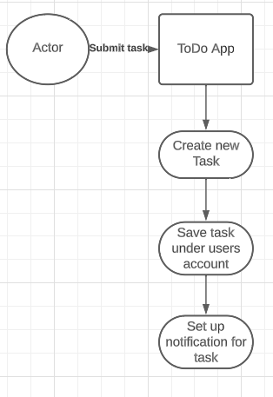

**Use Case 2:** View Task Details

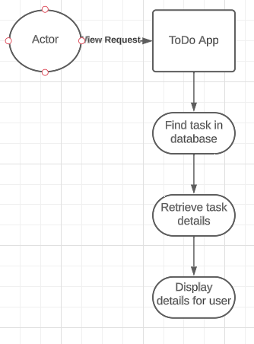

**Use Case 3:** Mark task as complete

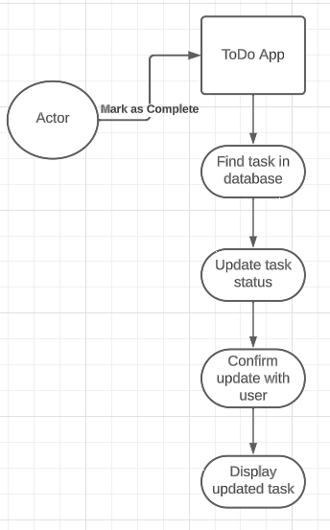

**Use Case 4:** Edit task details

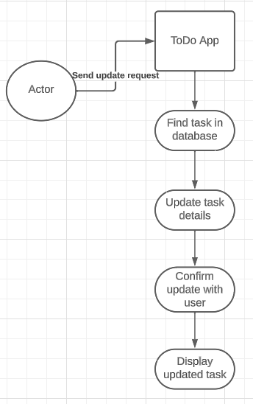

**Use Case 5:** Delete a task

